1.Write a pseudocode and produce flowchart to calculate the area of the rectangle.

Start

Insert length of rectangle (length)

Insert breadth of rectangle (breadth)

area= length * breadth

Print area

End

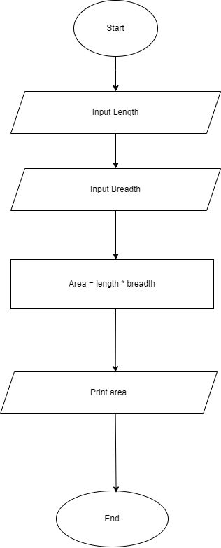

2. Write a pseudocode and produce flowchart to display the area of four walls.

Start

Insert length of the wall (length)

Insert breadth of the wall (breadth)

Insert height of the wall (height)

Area of walls:

area of wall 1 = length * breadth

area of wall 2 = length * breadth

area of wall 3 = length * breadth

area of wall 4 = length * breadth

Total area = area of wall 1 + area of wall 2 + area of wall 3 + area of wall 4

Print Total area

End

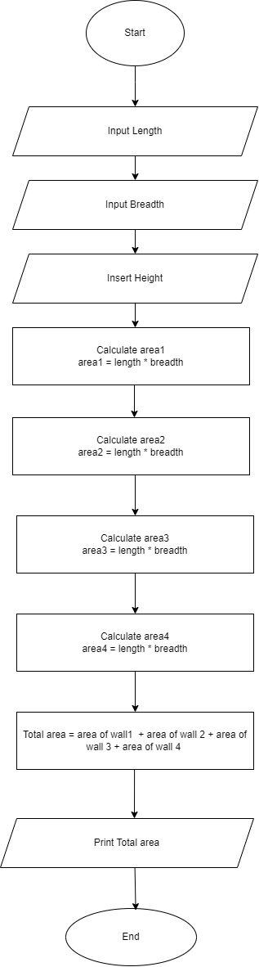

3. Write a pseudocode and produce flowchart to calculate the perimeter of the circle.

Start

pi = 3.14

Insert the radius of Circle (radius)

Perimeter = 2 * pi * radius

Print Perimeter

End

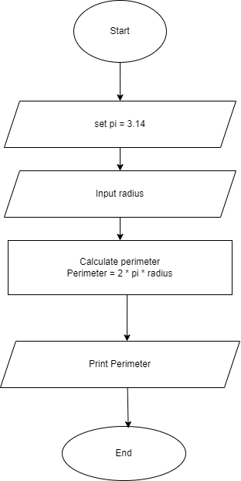

4. Write a pseudocode and produce flowchart to ask the user to enter a number and display its square.

Start

Print "Enter a number"

Store the number in variable called "number"

square = number * number

print "The required number is", square

End

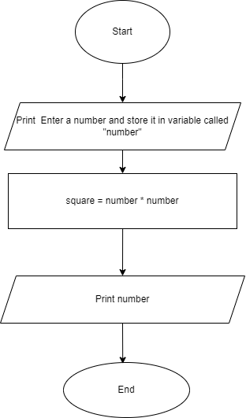

5. Write a pseudocode and produce flowchart to display the area of a triangle when three sides are given.

Start

Insert the perpendicular of triangle (perpendicular)

Insert the base of the triangle (base)

Insert the hypoteneous of the triangle (hypoteneous)

area = ( base * hypoteneous) / 2

Print area

End

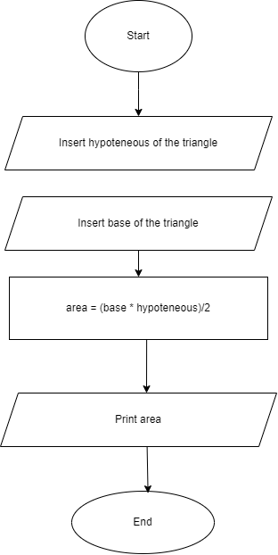

6. Write a pseudocode/flowchart to identify if the given number is odd or even.

Start

Insert a number and store the number in variable "num"

if the number is divisible by 2 (number % 2 == 0)

print the number is even

Else

Print the number is odd

End

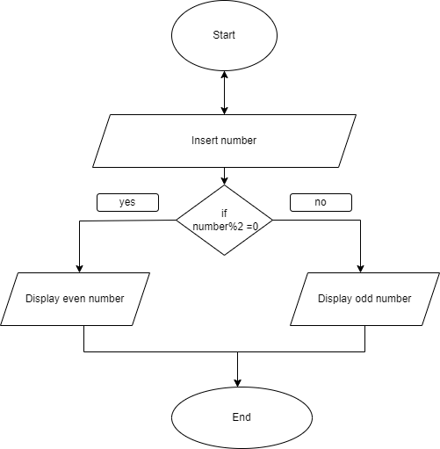

7. Write a pseudocode/flowchart and a python program to identify if a number is prime or not.

Start

End

8. Write a pseudocode/flowchart to identify if a person of given age is eligible to cast a vote or not.

Start

Insert the age of the person and store it in variable "age"

if the age >= 16

Print the person is eligible to vote

Else

Print the person is not eligible to vote.

End

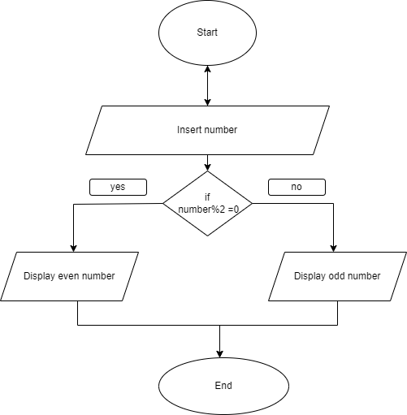

9. Write a pseudocode/flowchart to print factors of a given number. ***********

Start

Initialize a number i = 1

Print Insert a number and store it in variable "num"

for ( i = 1 to n/2 and i+1)

Check if (n%i==0)

print i

else i+1

else End

10. What is the intuition behind assigning a value to a variable in python?

-> to store data and for easy call in the program

11. What are some common data types in Python, and when would you use each one?

-> data types:

int: store integer

float: store decimal number

str: stores text

bool: represents true or false

list:

tuple:

dictionery: collection of key value pairs

null: null value

12. Discuss the differences between mutable and immutable data types, and give an example of each.

Mutable datatypes are those datatypes which can be changed without changing its identity

Eg: list, dictionary

Immutable datatypes are those datatypes which cannot be changed once its created.

Rg: tuple, int, float

13. Python is a dynamically typed language. What does this statement mean?

This means we don’t have declare the datatype of the variable...

14. Write a python program to prompt the user for input number and print square of that particular integer.

def square_number():

num = int(input("Enter a number"))

square = num * num

print ( " the square is:,square)

15. Write a python program to calculate a simple interest rate.

def calculate_simple_interest(principle,time,rate)"

interest = (principle * time* rate)/100

return interest

def main():

try:

principle = float(input("Enter the amount of principle:"))

time = float(input("enter the time duration(in years):"))

rate = float(float("enter the rate(in percentage):"))

simple_interest = calculate_simple_interest(principle,time,rate)

print(f"the interest is: {simple_interest:}")

except ValueError:

print("Invalid input.")

if __name__ == "__main__":

main()

16. Write a python program to display the circumference of a circle. (import math module) ****

import math

def calculate_circumference(radius):

circumference = 2 * math.pi * radius

return circumference

def main():

try:

radius=float(input("enter the radius of circle"))

circumference = calculate_circumference(radius)

print(f"the circumference of circle is: {circumference:}")

except ValueError:

print("Invalid input.")

if __name__ == "__main__":

main()

17. Write a python program to ask in kilograms and convert into grams.

def kg_to_g(kilogram):

kilogram = kilogram * 1000

return kilogram

def main():

try:

kilogram = float(input("enter the weight in kg:"))

grams = kg_to_g(kilogram)

print(f" {kilogram} is equal to {grams} grams")

except ValueError:

print("invalid value")

if __name__ == "__main__":

main()

18. Write a python program to display the area of the triangle.

def area_of_triangle(breadth, height):

area = (breadth * height)/2

return area

def main():

try:

breadth = float(input("enter the breadth of the triangle:"))

height = float(input("enter the height of the triangle"))

area = area_of_triangle(breadth, height)

print(f" area of triangle is: {area}")

except ValueError:

print("invalid value")

if __name__ == "__main__":

main()

19. Write a python program to prompt user to input their name and display “Hello &;NAME;”

def main():

user_name = input("Enter your name: ")

print(f"Hello {user_name}!")

if __name__ == "__main__":

main()